
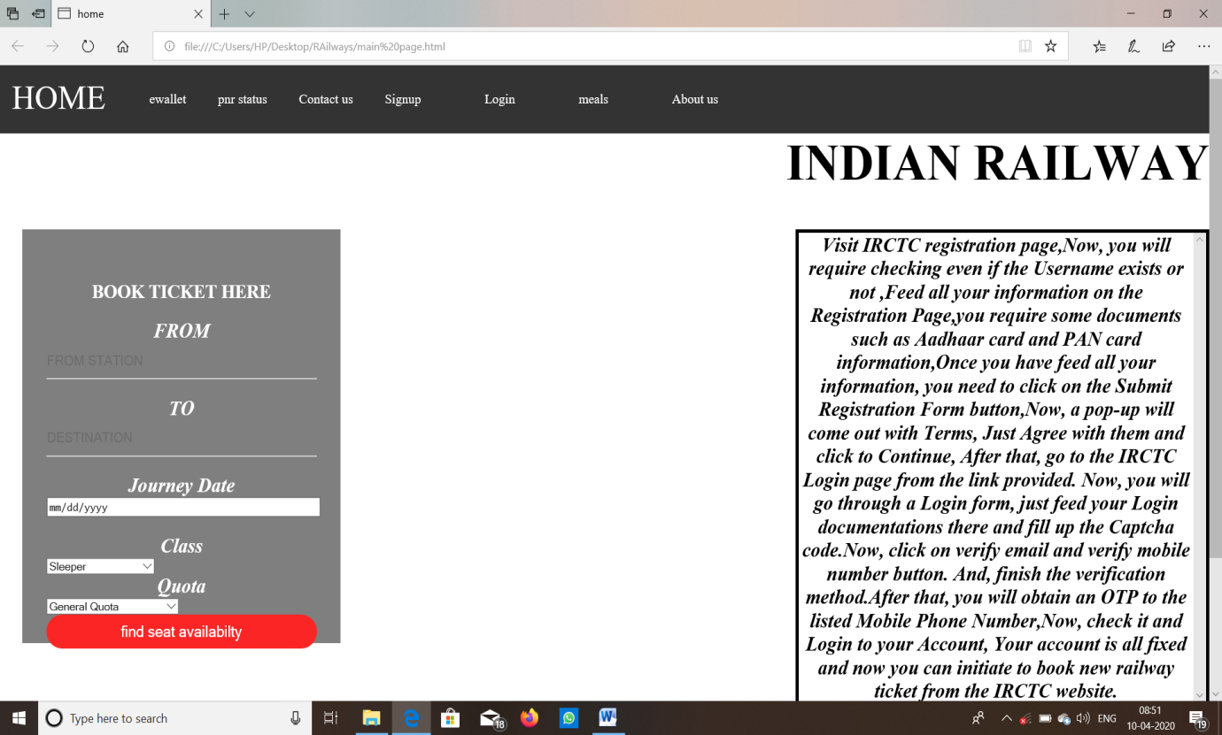
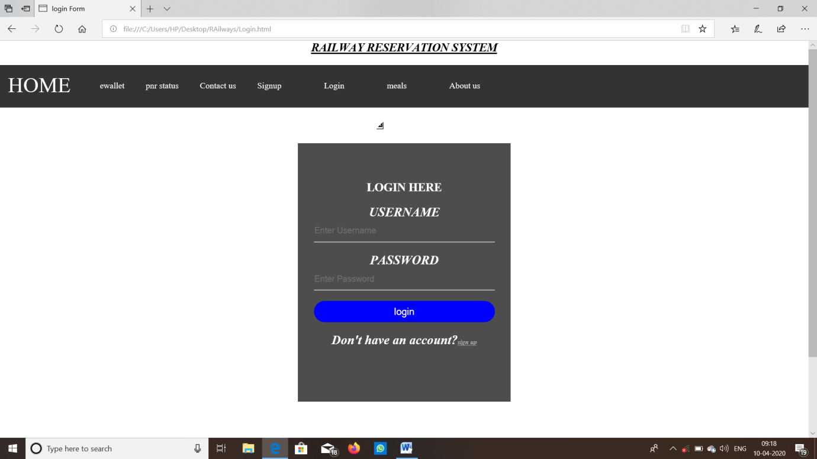
pg.no 1
Topic:Online Train Reservation System
End Term Report

Name of the Candidate Section Rollno:
Sathi Daddy Sri Reddy K19HKB 56
Yeashwanth Babu K19HKB 57
Vivek Singh K19HKB 55

LOVELY PROFESSIONAL UNIVERSITY

Department of Intelligent systems,
School of Computer Science and Engineering,
Lovely professional University, Jalandhar,
April-2020.

Pg.no 2

Student declaration

This is to declare that this report has been written by me/us. No part of the report is copied from other sources. All information included from other sources have been duly acknowledged. I/We aver that if any part of the report is found to be copied, I/we are shall take full responsibility for it.

TABLE OF CONTENTS
PAGE NO. 3

- Abstract
- Introduction
- Literature Review
- Proposed Methodology
- Result and Discussion
- Analysis
- Work division among students
- Conclusion
- References

Pg.no 4

BONAFIDE CERTIFICATE

Certified that this project report “Online Railway Ticket Reservation System” is the bonafide work of “ Sathi Daddy Sri Reddy, Yeashwanth Babu ,Vivek Singh ” who carried out the project work under my supervision.

Pg.no 5
Abstract

Objectives :
In this web designing project ,we are designing a web page which will provide an interface to reserve railway tickets . we are going to create a web page which works as an interface and links all the pages which are used for booking train tickets.
This serves as a platform for the users to reserve the train tickets for the desired date and time through the online system.
This webpage serves for booking tickets with ease and makes the
user have a good experience in booking the required tickets.
Advantages:
This helps the users to make their journey’s has a probable scope for good planning, as this website makes it easy for the users, to book train tickets and plan the respective tours of the users accordingly It also shows the users about the availability of trains and their booking status . This makes the user get benefitted in choosing the best way for their travel.
This helps in making the more efficient web pages available for the people . This makes us more discoverable . Since many people travel everyday, there is a great demand for the ticket reservation platforms which is fulfilled by these websites

Pg no 6
Introduction :
In this project , we have made the demo model of a webpage which can withstand with the present day working websites . The idea of this model is to make an easy user interface which can be accessed by everyone easily.
In brief, the page we have designed can be used for further linking with the database and can be used as an official website .In general, online ticket reservation platforms are very busy as there is a lot of usage of those sites in everyday life.
So, this module gives us the information about how we can create a simple webpage with all the required components needed.
Our page works in a simple way , where the user gets logs into his account and then look for his destination from where he needs to travel and he can choose down the date of journey and after submitting the details, the payment way is shown and after that the tickets are booked successfully and the site returns to the homepage after the completion of this whole process.

pg no 7

The objective of the project assigned is to make a simple user interface for railway reservation system . In order to that, we have made an interface where the users can easily understand the modules in the site and can book their tickets easily .
The interface we have designed will be official enough with all the basic required modules in that like home module and many paths like choosing destinations and journey path etc where the process is not so complex in developing the interface but also for the users to use the webpage. In general, the work of any online platform is to decrease the efforts of the customer , as in traditional manner the efforts might increase and also time consuming . This time consumption and human efforts can be decreased by these online platforms .In order to achieve that, these interfaces have been developed.

pg.no-8

DESCRIPTION OF THE PROJECT

Our project consists of the following modules :
->Home module
->ewallet module
->pnr status module
->contact us module
->Sign in module
->login module
->About us

Home module :
In the home page, all the modules are displayed and the page also shows the information and news about the railway system ,there will be a portal displayed in the home page so that ,one can check the seat availabilty . The other modules that are displayed on the home page will direct us into the required page.
Ewallet module :
In this module , the details and description of the e-wallet are displayed and required conditions are shown for ewallet scheme .This page also shows the benefits of having an ewallet and describes the steps to be taken for having an e wallet and booking a train ticket using e-wallet.
PNR status module :
In this module , a search bar is given where we can search the train status by entering the pnr number of the train .

Contact us module:
In this module, the details of the creators of the website are displayed so that they can answer the queries of the users and can also be contacted in order to improve the interface by getting suggestions from the users.

Signup module:
In this module , a list of fields to be filled are displayed
which are required for creating an account in the website ,so that one can access the ticket booking through his /her data which in turn helps the website officials to keep the data of the total number of the users .
Login module :
In this module, the user is asked to fill his/her existing username and password of his account so as to move to further process and book the tickets.
About us module:
In this, the details of the website and the achievements and services by the website are displayed.

Description of work division in terms of roles :
The project has been designed by three members ,in which the project synopsis has been made by the three of us ,where the work has been equally divided among us and in the website interface creation, the login module has been designed by Yeashwanth Babu K19HKB57,Vivek Singh K19HKB55 and the homepage has been done by Sathi Daddy Sri Reddy K19HKB56...
Sign up module, about us – by Yeashwanth Babu.
Contact Us ,Booking Ticket –by Vivek Singh
Login module, pnr status module ,Meals module–by Sathi Daddy Sri Reddy

The work has been divided into three categories and have been performed by all the three members of our group .

Literature Review :
Technologies and framework used.

The framework and technology used in this project is html , css , javascript.

Implementation of work project

HOME PAGE:
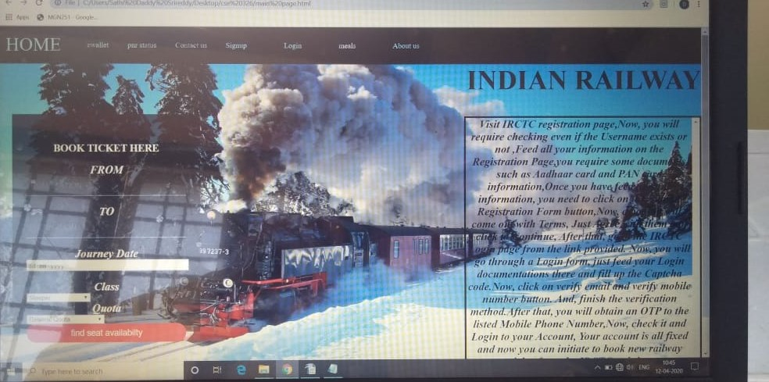

SIGN UP PAGE:

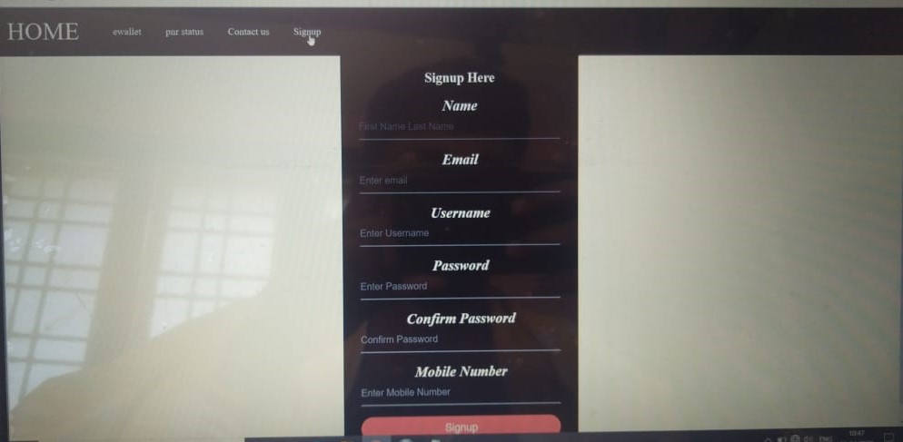
LOGIN PAGE:

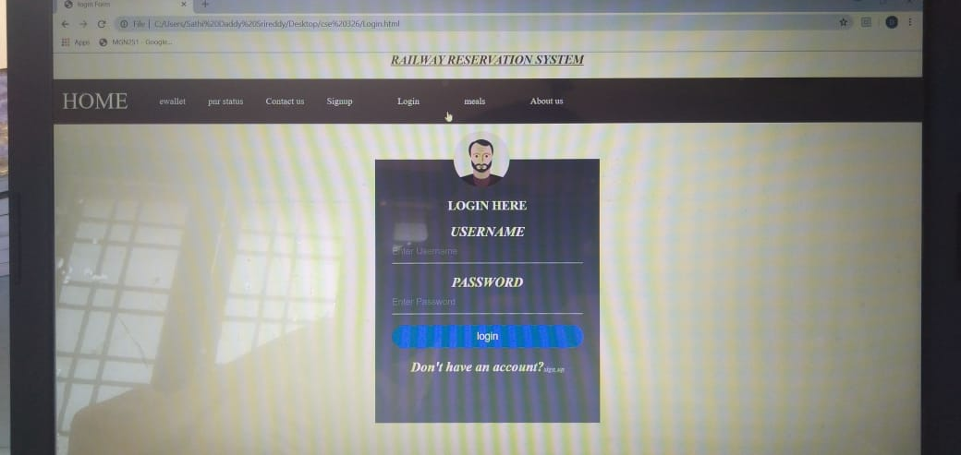

PNR ENQUIRY:

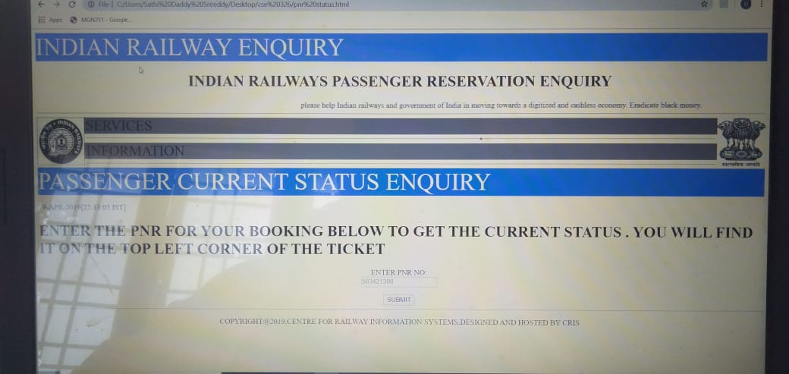

AVAILABILITY OF MEALS PAGE:

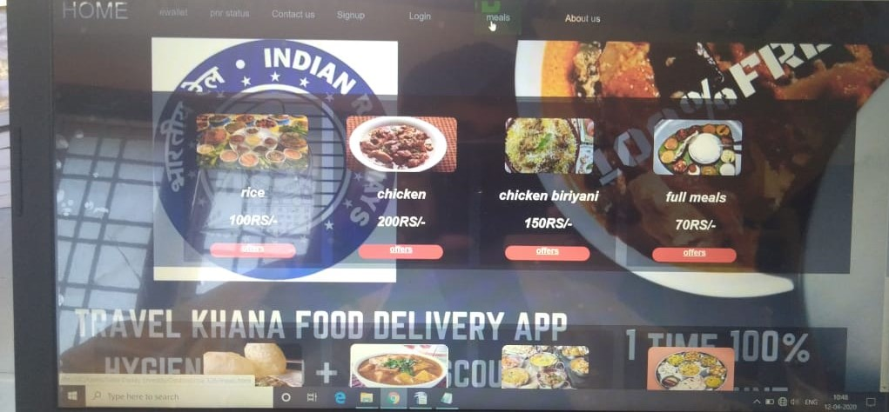

Proposed methodology :
In making this project, we have used the components of html ,css and java and the process of working of the website goes on in the following way .First of all ,the homepage is displayed where one can find the seat availability of the train in between the desired stations. After that one can go into his account by logging in ,if he already has an account in that website by providing the required details ,else he can create his own account in that website by signing in ,after the sign up the user will be taken into the page where one can find about the trains details and the available tickets and can book through the online portal in a simple way , thus leading transparency in everyway.

Analysis of the project
This simple webpage interface is easily accessible and understandable. If this is implemented completely with the connection of a database, this can compete with the webpages in the present world and can be useful to the people ,since there is lot of need of such websites for the people for simplification of their life.

Conclusion :
This kind of webpages helps everyone in making their tasks easy and convenient , thus we can say that this can also help in decreasing the inconvenience caused by having very few number of online portals ,since these can help in increasing the online transactional ticket bookings.

References:
We have used the online platforms like w3 schools to present in a special way and also used the notes given to us ,in making the kind of website model we have done here.

Thank you.

